DTSC 671: AI Solutions in the Cloud

SUBMISSION TEMPLATE:
Text Extraction with Amazon Textract

Select File > Make a copy to edit the template and add your screenshots. Download the completed template as a PDF document to submit to Brightspace.

In every screenshot, include your AWS username that appears in the upper right corner. Example:

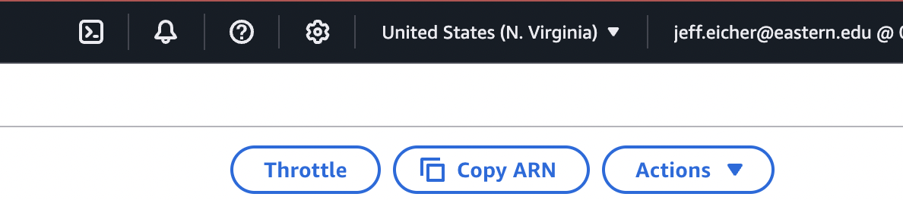

If any one screenshot is missing this identification, the entire assignment will be scored no higher than 70%.

Points totals are provided at the start of each question. You score either full credit or 0 points; there is no partial credit for each question.

- [10 points] In the space below, provide a screenshot of the Lambda function diagram (with trigger and destination).

- [10 points] In the space below, provide both a screenshot of the beginning of your Lambda code with your account showing, then copy-paste your full lambda code below the screenshot. Note: when writing your function be sure that your code picks up only the skills in the resume, not the symbols ( | or - ).

- [10 points] In the space below, provide a screenshot of the CloudWatch log streams for your Lambda function. Fit as many as you can in the screenshot.

- [10 points] In the space below, provide a screenshot of the CloudWatch stream that functioned without errors.

- [10 points] In the space below, provide a screenshot of IAM role permissions for the Lambda function.

- [25 points] In the space below, provide a screenshot of the CSV file in your output bucket.

- [25 points] Provide a screenshot of your CSV file’s output (which extracted fields). Fit all of the information in the screenshot.

